Research Document (MySQL Spatial Data Types, Storing spatial data and using it to create a Restful Web service)

**Aim:** The aim of the document is to successfully research ways to be able to store geo spatial dats in MySQL database

**Why:** Currently (24 Feb, 2017) I have been using SAP Hana HCP but the issue is its not free and is very expensive to move from trail to pro version, so the better alternative is MySQL if I am successfully able to implement what I was able to do with HCP. And, the advantages will be free of cost, HCP trail needs restart every 12 hours and auto deletes after 6 days which is a big disadvantage, MySQL will allow 99% uptime for web service.

******************************************************

## Importance of the external resources used based on Level:

***Level (High) – Very helpful and important***

***Level (Medium) – Important and Some what helpful and related***

***Level (Low) – Helped to see some light, but not very useful resource.***

******************************************************

Table of Contents

Importance of the external resources used based on Level: 1

************Creating a table with geometry***************** 1

Query to show the columns in the table: 1

***Quite close to solving problem of inserting spatial data into MySQL**** 2

****Working SQL Statement to insert spatial data in MySQL (Polygon and Point)****** 2

## ************Creating a table with geometry*****************

create table myspatialdata (id integer(7), bpolygon Geometry, mpoint Geometry);

******************************************************

## Query to show the columns in the table:

[**SHOW**](https://eu72.hostblast.net:2083/cpsess4597370376/3rdparty/phpMyAdmin/url.php?url=http%3A%2F%2Fdev.mysql.com%2Fdoc%2Frefman%2F5.6%2Fen%2Fshow.html&token=374f924831d152b054de90762c13843c) **COLUMNS** **FROM** myspatialdata

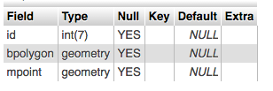

## ***Quite close to solving problem of inserting spatial data into MySQL****

INSERT INTO myspatialdata (id, bpolygon, mpoint)

VALUES ('1','POLYGON(18 23, 0 0, 3 6, 8 9, 18 23)','POINT(18, 23)');

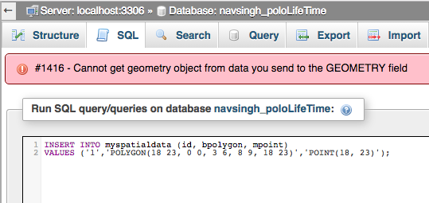

## ****Working SQL Statement to insert spatial data in MySQL (Polygon and Point)******

INSERT INTO myspatialdata (id, bpolygon, mpoint)

VALUES (1,GeomFromText('POLYGON(18 23, 0 0, 3 6, 8 9, 18 23)'),GeomFromText('POINT(18, 23)'));

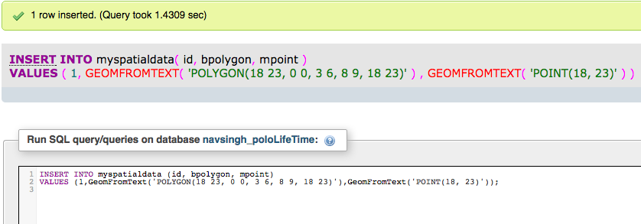

INSERT INTO myspatialdata (id, bpolygon, mpoint)

VALUES (2,GeomFromText('POLYGON(-74.13591384887695 40.93750722242824,-74.13522720336914 40.929726129575016,-74.15102005004883 40.9329683629703,-74.14329528808594 40.94256444133327)'),GeomFromText('POINT(-74.13591384887695,40.93750722242824)'));

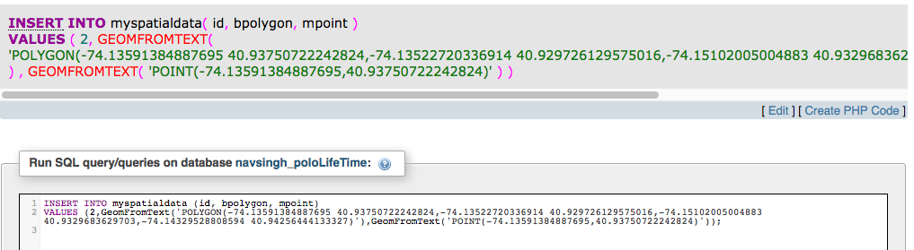

Note: Useful documentation on MySQL Spatial Data Types

<http://www.w3resource.com/mysql/mysql-spatial-data-types.php>

(Level: High)

Inserting Coordinates into MySQL (Stack Flow)

<http://stackoverflow.com/questions/15453084/inserting-coordinates-into-mysql-polyfromtext-sql-syntax-error-returning-nul>

(Level: Low)

******The end of the Inserting Spatial data like Polygon and Point in to database table*****

*************************************************

RESEARCH RESULTS: FAILED

*************************************************

Inserting Geo-spatial Polygon into the MySQL Database

INSERT INTO `Buildings` (`Name`, `Shape`) VALUES ('Apt 15', PolyFromText('POLYGON((50.866753 5.686455, 50.859819 5.708942, 50.851475 5.722675, 50.841611 5.720615, 50.834023 5.708427, 50.840744 5.689373, 50.858735 5.673923, 50.866753 5.686455))'));

Reference: <https://gis.stackexchange.com/questions/23900/how-to-add-polygon-in-mysql-database>

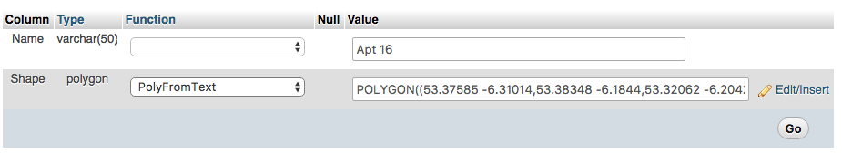

RESEARCH RESULTS: PASSED (Working)

# Resources for Functioanal Requirements

Requirement 7:

Requirement 8: Photo Upload

Image upload example with Swift and PHP - http://swiftdeveloperblog.com/image-upload-example/

Requirement 9:

Cocoapods

Chameleon

<http://theiostimes.com/advent-calendar/chameleon.html>

Alomofire and SwiftyJSON

<http://ashishkakkad.com/2015/10/how-to-use-alamofire-and-swiftyjson-with-swift/>

<https://grokswift.com/rest-with-alamofire-swiftyjson/>

SwiftPhoto Gallery

<https://github.com/Inspirato/SwiftPhotoGallery>

# Final Report Database

Database Type: MySQL

Language used: SQL

Database name: navsingh_MRPro

Tables:

|  |  |
| --- | --- |
| Table Name | Description |
| mrp_companies | Stores company information |
| mrp_buildings | Stores buildings coordinates and other relevant information |
| mrp_meeting_rooms | Stores meeting rooms coordinates and other relevant information |
|  |  |
|  |  |
|  |  |
|  |  |

Tools: Using phpMyAdmin

Explain what phpMyAdmin is ? point to the documentation ?

## Tables

1- Companies Table (mrp_companies) to store all the information regarding the different companies this will allow us to –

1. Use app for multiple companies/organization’s/institutions by storing data for different companies and use it in a single app (example- city council can buy the app to list the different public properties/companies and the available buildings/meeting rooms in them)
2. or just use the app for one company (example – Our college – for NCI use only can be deployed as an internal app)

Using phpMyAdmin creating the table

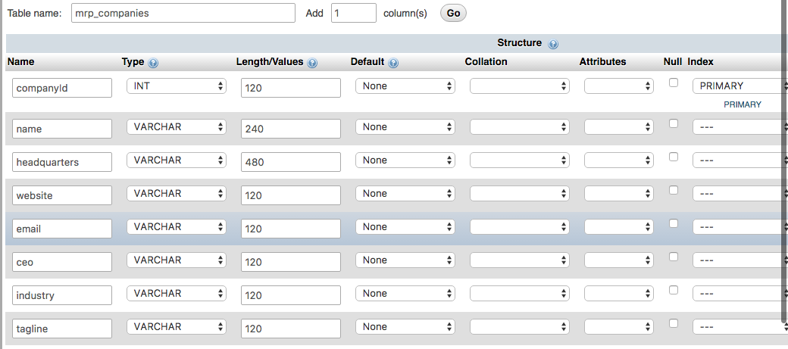

Companies (mrp_companies) table structure

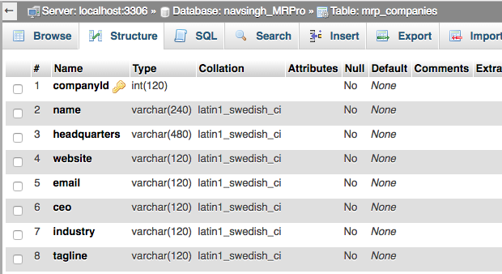

[CREATE](https://eu72.hostblast.net:2083/cpsess5429043615/3rdparty/phpMyAdmin/url.php?url=https://dev.mysql.com/doc/refman/5.5/en/create-table.html) [TABLE](https://eu72.hostblast.net:2083/cpsess5429043615/3rdparty/phpMyAdmin/url.php?url=https://dev.mysql.com/doc/refman/5.5/en/create-table.html) `navsingh_MRPro`.`mrp_companies` ( `companyId` [INT](https://eu72.hostblast.net:2083/cpsess5429043615/3rdparty/phpMyAdmin/url.php?url=https://dev.mysql.com/doc/refman/5.5/en/numeric-types.html)(120) [NOT](https://eu72.hostblast.net:2083/cpsess5429043615/3rdparty/phpMyAdmin/url.php?url=https://dev.mysql.com/doc/refman/5.5/en/logical-operators.html#operator_not)NULL , `name` [VARCHAR](https://eu72.hostblast.net:2083/cpsess5429043615/3rdparty/phpMyAdmin/url.php?url=https://dev.mysql.com/doc/refman/5.5/en/string-types.html)(240) [NOT](https://eu72.hostblast.net:2083/cpsess5429043615/3rdparty/phpMyAdmin/url.php?url=https://dev.mysql.com/doc/refman/5.5/en/logical-operators.html#operator_not) NULL , `headquarters` [VARCHAR](https://eu72.hostblast.net:2083/cpsess5429043615/3rdparty/phpMyAdmin/url.php?url=https://dev.mysql.com/doc/refman/5.5/en/string-types.html)(480) [NOT](https://eu72.hostblast.net:2083/cpsess5429043615/3rdparty/phpMyAdmin/url.php?url=https://dev.mysql.com/doc/refman/5.5/en/logical-operators.html#operator_not)NULL , `website` [VARCHAR](https://eu72.hostblast.net:2083/cpsess5429043615/3rdparty/phpMyAdmin/url.php?url=https://dev.mysql.com/doc/refman/5.5/en/string-types.html)(120) [NOT](https://eu72.hostblast.net:2083/cpsess5429043615/3rdparty/phpMyAdmin/url.php?url=https://dev.mysql.com/doc/refman/5.5/en/logical-operators.html#operator_not) NULL , `email` [VARCHAR](https://eu72.hostblast.net:2083/cpsess5429043615/3rdparty/phpMyAdmin/url.php?url=https://dev.mysql.com/doc/refman/5.5/en/string-types.html)(120) [NOT](https://eu72.hostblast.net:2083/cpsess5429043615/3rdparty/phpMyAdmin/url.php?url=https://dev.mysql.com/doc/refman/5.5/en/logical-operators.html#operator_not) NULL ,`ceo` [VARCHAR](https://eu72.hostblast.net:2083/cpsess5429043615/3rdparty/phpMyAdmin/url.php?url=https://dev.mysql.com/doc/refman/5.5/en/string-types.html)(120) [NOT](https://eu72.hostblast.net:2083/cpsess5429043615/3rdparty/phpMyAdmin/url.php?url=https://dev.mysql.com/doc/refman/5.5/en/logical-operators.html#operator_not) NULL , `industry` [VARCHAR](https://eu72.hostblast.net:2083/cpsess5429043615/3rdparty/phpMyAdmin/url.php?url=https://dev.mysql.com/doc/refman/5.5/en/string-types.html)(120) [NOT](https://eu72.hostblast.net:2083/cpsess5429043615/3rdparty/phpMyAdmin/url.php?url=https://dev.mysql.com/doc/refman/5.5/en/logical-operators.html#operator_not) NULL ,`tagline` [VARCHAR](https://eu72.hostblast.net:2083/cpsess5429043615/3rdparty/phpMyAdmin/url.php?url=https://dev.mysql.com/doc/refman/5.5/en/string-types.html)(120) [NOT](https://eu72.hostblast.net:2083/cpsess5429043615/3rdparty/phpMyAdmin/url.php?url=https://dev.mysql.com/doc/refman/5.5/en/logical-operators.html#operator_not) NULL , PRIMARY KEY (`companyId`)) ENGINE =MyISAM;

SQL Query for creating the table

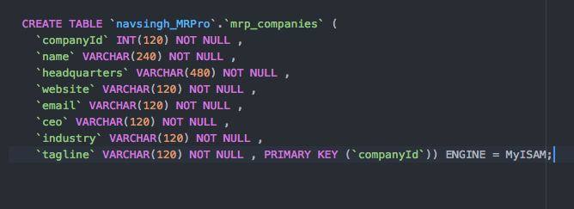

2 - Buildings table (mrp_buildings) to store all the information regarding buildings and also their co-ordinates (using geospatial features of MySQL – here we are using Polygon/Geometry)

Using phpMyAdmin creating the table

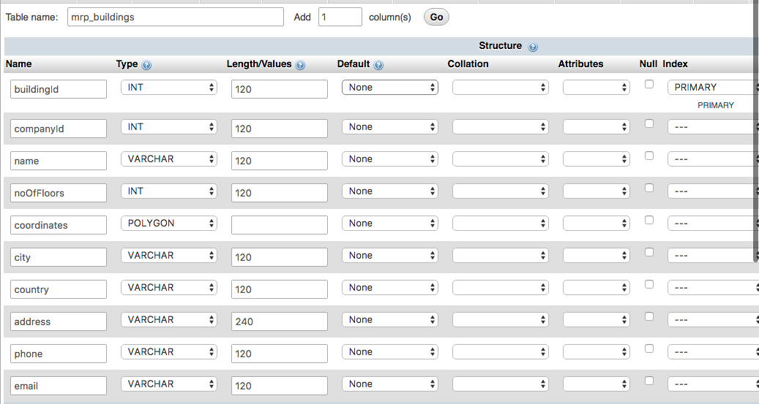

Building (mrp_buildings) table structure

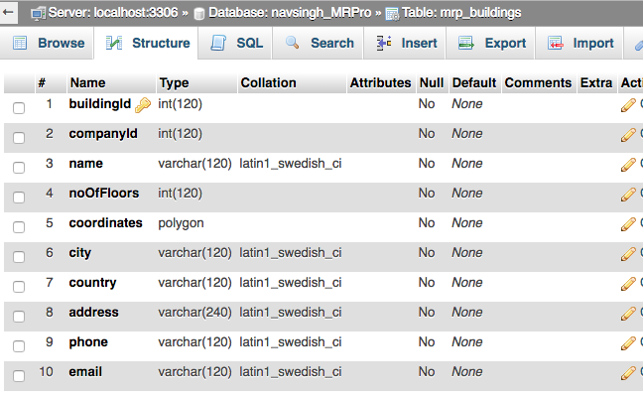

CREATE TABLE `navsingh_MRPro`.`mrp_meeting_rooms` (

`meetingRoomId`INT(120) NOT NULL ,

`buildingId` INT(120) NOT NULL ,

`name` VARCHAR(120)NOT NULL ,

`floorNumber` INT(120) NOT NULL ,

`coordinates` POINT NOT NULL ,

`capacity` INT(120) NOT NULL ,

`type` VARCHAR(120) NOT NULL ,

`phone` VARCHAR(120) NOT NULL ,

`email` VARCHAR(120) NOT NULL ,

`directions` VARCHAR(480) NOT NULL , PRIMARY KEY (`meetingRoomId`))ENGINE = MyISAM;

SQL Query for creating the table

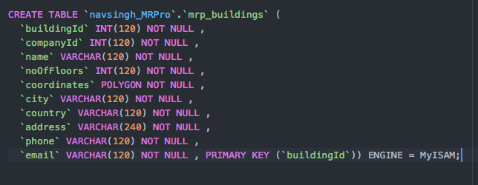

3 – Meeting Rooms Table (mrp_meeting_rooms) to store information regarding meeting rooms

Using phpMyAdmin creating the table

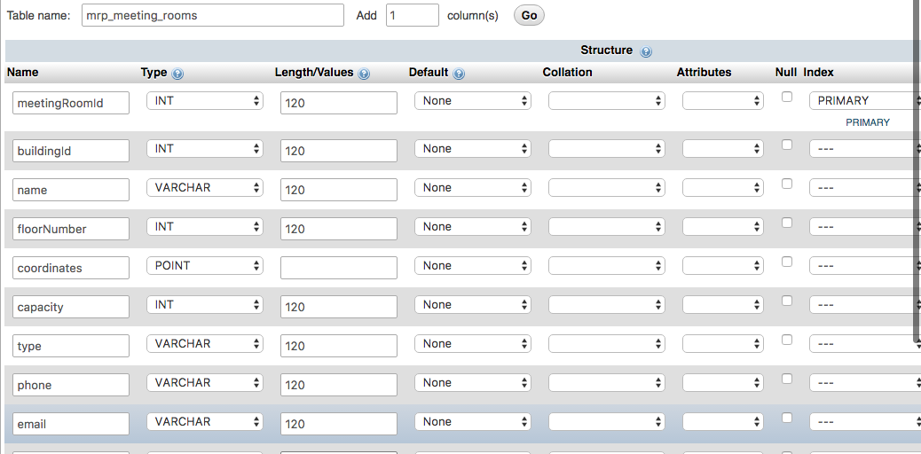

Meeting Rooms (mrp_meeting_rooms) table structure

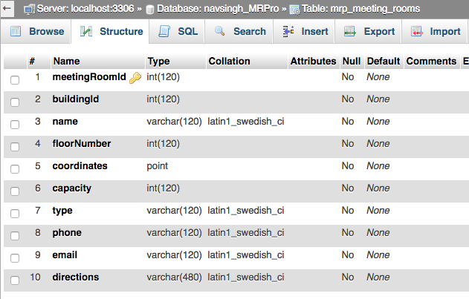

[CREATE](https://eu72.hostblast.net:2083/cpsess5429043615/3rdparty/phpMyAdmin/url.php?url=https://dev.mysql.com/doc/refman/5.5/en/create-table.html) [TABLE](https://eu72.hostblast.net:2083/cpsess5429043615/3rdparty/phpMyAdmin/url.php?url=https://dev.mysql.com/doc/refman/5.5/en/create-table.html) `navsingh_MRPro`.`mrp_meeting_rooms` ( `meetingRoomId`[INT](https://eu72.hostblast.net:2083/cpsess5429043615/3rdparty/phpMyAdmin/url.php?url=https://dev.mysql.com/doc/refman/5.5/en/numeric-types.html)(120) [NOT](https://eu72.hostblast.net:2083/cpsess5429043615/3rdparty/phpMyAdmin/url.php?url=https://dev.mysql.com/doc/refman/5.5/en/logical-operators.html#operator_not) NULL , `buildingId` [INT](https://eu72.hostblast.net:2083/cpsess5429043615/3rdparty/phpMyAdmin/url.php?url=https://dev.mysql.com/doc/refman/5.5/en/numeric-types.html)(120) [NOT](https://eu72.hostblast.net:2083/cpsess5429043615/3rdparty/phpMyAdmin/url.php?url=https://dev.mysql.com/doc/refman/5.5/en/logical-operators.html#operator_not) NULL , `name` [VARCHAR](https://eu72.hostblast.net:2083/cpsess5429043615/3rdparty/phpMyAdmin/url.php?url=https://dev.mysql.com/doc/refman/5.5/en/string-types.html)(120)[NOT](https://eu72.hostblast.net:2083/cpsess5429043615/3rdparty/phpMyAdmin/url.php?url=https://dev.mysql.com/doc/refman/5.5/en/logical-operators.html#operator_not) NULL , `floorNumber` [INT](https://eu72.hostblast.net:2083/cpsess5429043615/3rdparty/phpMyAdmin/url.php?url=https://dev.mysql.com/doc/refman/5.5/en/numeric-types.html)(120) [NOT](https://eu72.hostblast.net:2083/cpsess5429043615/3rdparty/phpMyAdmin/url.php?url=https://dev.mysql.com/doc/refman/5.5/en/logical-operators.html#operator_not) NULL , `coordinates` POINT [NOT](https://eu72.hostblast.net:2083/cpsess5429043615/3rdparty/phpMyAdmin/url.php?url=https://dev.mysql.com/doc/refman/5.5/en/logical-operators.html#operator_not)NULL , `capacity` [INT](https://eu72.hostblast.net:2083/cpsess5429043615/3rdparty/phpMyAdmin/url.php?url=https://dev.mysql.com/doc/refman/5.5/en/numeric-types.html)(120) [NOT](https://eu72.hostblast.net:2083/cpsess5429043615/3rdparty/phpMyAdmin/url.php?url=https://dev.mysql.com/doc/refman/5.5/en/logical-operators.html#operator_not) NULL , `type` [VARCHAR](https://eu72.hostblast.net:2083/cpsess5429043615/3rdparty/phpMyAdmin/url.php?url=https://dev.mysql.com/doc/refman/5.5/en/string-types.html)(120) [NOT](https://eu72.hostblast.net:2083/cpsess5429043615/3rdparty/phpMyAdmin/url.php?url=https://dev.mysql.com/doc/refman/5.5/en/logical-operators.html#operator_not) NULL ,`phone` [VARCHAR](https://eu72.hostblast.net:2083/cpsess5429043615/3rdparty/phpMyAdmin/url.php?url=https://dev.mysql.com/doc/refman/5.5/en/string-types.html)(120) [NOT](https://eu72.hostblast.net:2083/cpsess5429043615/3rdparty/phpMyAdmin/url.php?url=https://dev.mysql.com/doc/refman/5.5/en/logical-operators.html#operator_not) NULL , `email` [VARCHAR](https://eu72.hostblast.net:2083/cpsess5429043615/3rdparty/phpMyAdmin/url.php?url=https://dev.mysql.com/doc/refman/5.5/en/string-types.html)(120) [NOT](https://eu72.hostblast.net:2083/cpsess5429043615/3rdparty/phpMyAdmin/url.php?url=https://dev.mysql.com/doc/refman/5.5/en/logical-operators.html#operator_not) NULL ,`directions` [VARCHAR](https://eu72.hostblast.net:2083/cpsess5429043615/3rdparty/phpMyAdmin/url.php?url=https://dev.mysql.com/doc/refman/5.5/en/string-types.html)(480) [NOT](https://eu72.hostblast.net:2083/cpsess5429043615/3rdparty/phpMyAdmin/url.php?url=https://dev.mysql.com/doc/refman/5.5/en/logical-operators.html#operator_not) NULL , PRIMARY KEY (`meetingRoomId`))ENGINE = MyISAM;

SQL Query for creating the table

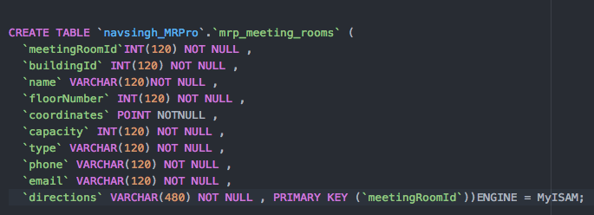

Users table (mrp_users) For storing app users

[CREATE](https://eu72.hostblast.net:2083/cpsess5429043615/3rdparty/phpMyAdmin/url.php?url=https://dev.mysql.com/doc/refman/5.5/en/create-table.html) [TABLE](https://eu72.hostblast.net:2083/cpsess5429043615/3rdparty/phpMyAdmin/url.php?url=https://dev.mysql.com/doc/refman/5.5/en/create-table.html) `navsingh_MRPro`.`mrp_users` ( `userId` [INT](https://eu72.hostblast.net:2083/cpsess5429043615/3rdparty/phpMyAdmin/url.php?url=https://dev.mysql.com/doc/refman/5.5/en/numeric-types.html)(120) [NOT](https://eu72.hostblast.net:2083/cpsess5429043615/3rdparty/phpMyAdmin/url.php?url=https://dev.mysql.com/doc/refman/5.5/en/logical-operators.html#operator_not) NULL ,`name` [VARCHAR](https://eu72.hostblast.net:2083/cpsess5429043615/3rdparty/phpMyAdmin/url.php?url=https://dev.mysql.com/doc/refman/5.5/en/string-types.html)(120) [NOT](https://eu72.hostblast.net:2083/cpsess5429043615/3rdparty/phpMyAdmin/url.php?url=https://dev.mysql.com/doc/refman/5.5/en/logical-operators.html#operator_not) NULL , `accountType` [VARCHAR](https://eu72.hostblast.net:2083/cpsess5429043615/3rdparty/phpMyAdmin/url.php?url=https://dev.mysql.com/doc/refman/5.5/en/string-types.html)(120) [NOT](https://eu72.hostblast.net:2083/cpsess5429043615/3rdparty/phpMyAdmin/url.php?url=https://dev.mysql.com/doc/refman/5.5/en/logical-operators.html#operator_not) NULL ,`email` [VARCHAR](https://eu72.hostblast.net:2083/cpsess5429043615/3rdparty/phpMyAdmin/url.php?url=https://dev.mysql.com/doc/refman/5.5/en/string-types.html)(120) [NOT](https://eu72.hostblast.net:2083/cpsess5429043615/3rdparty/phpMyAdmin/url.php?url=https://dev.mysql.com/doc/refman/5.5/en/logical-operators.html#operator_not) NULL , `phone` [VARCHAR](https://eu72.hostblast.net:2083/cpsess5429043615/3rdparty/phpMyAdmin/url.php?url=https://dev.mysql.com/doc/refman/5.5/en/string-types.html)(120) [NOT](https://eu72.hostblast.net:2083/cpsess5429043615/3rdparty/phpMyAdmin/url.php?url=https://dev.mysql.com/doc/refman/5.5/en/logical-operators.html#operator_not) NULL ,`password` [VARCHAR](https://eu72.hostblast.net:2083/cpsess5429043615/3rdparty/phpMyAdmin/url.php?url=https://dev.mysql.com/doc/refman/5.5/en/string-types.html)(240) [NOT](https://eu72.hostblast.net:2083/cpsess5429043615/3rdparty/phpMyAdmin/url.php?url=https://dev.mysql.com/doc/refman/5.5/en/logical-operators.html#operator_not) NULL , `token` [VARCHAR](https://eu72.hostblast.net:2083/cpsess5429043615/3rdparty/phpMyAdmin/url.php?url=https://dev.mysql.com/doc/refman/5.5/en/string-types.html)(240) [NOT](https://eu72.hostblast.net:2083/cpsess5429043615/3rdparty/phpMyAdmin/url.php?url=https://dev.mysql.com/doc/refman/5.5/en/logical-operators.html#operator_not) NULL ,`companyId` [INT](https://eu72.hostblast.net:2083/cpsess5429043615/3rdparty/phpMyAdmin/url.php?url=https://dev.mysql.com/doc/refman/5.5/en/numeric-types.html)(120) [NOT](https://eu72.hostblast.net:2083/cpsess5429043615/3rdparty/phpMyAdmin/url.php?url=https://dev.mysql.com/doc/refman/5.5/en/logical-operators.html#operator_not) NULL , PRIMARY KEY (`userId`)) ENGINE = MyISAM;

Using phpMyAdmin creating the table

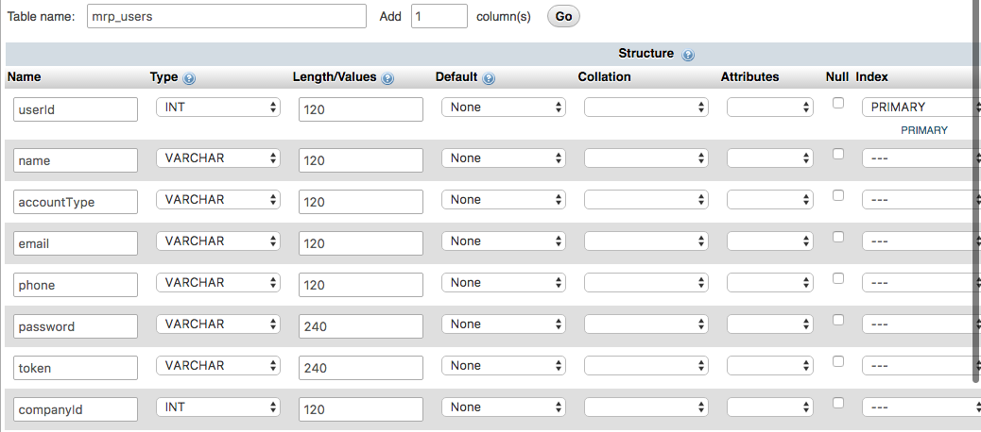

SQL Query for creating the table

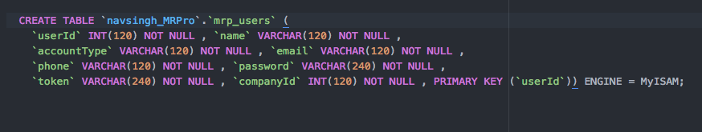

Users (mrp_users) table structure

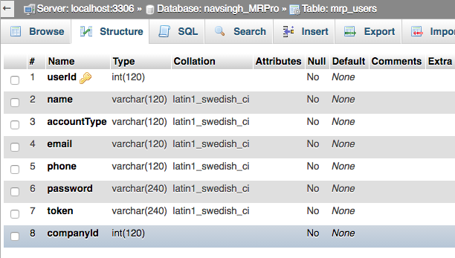

## Inserting Data into Tables

### Inserting data into mrp_buildings table

INSERT INTO `mrp_buildings` (`buildingId`, `companyId`, `name`, `noOfFloors`, `coordinates`, `city`, `country`, `address`, `phone`, `email`) VALUES ('1', '1', 'National College of Ireland', '4', PolyFromText('POLYGON((33.294974 -2.426631, 53.294847 -6.426419, 73.294289 -6.426888, 13.294326 -6.427194, 43.294974 -6.426631, 33.294974 -2.426631))'), 'Dublin', 'Ireland', 'Mayor Street, IFSC, Dublin 1, D01 Y300', '01449 8500', 'admissions@ncirl.ie ');

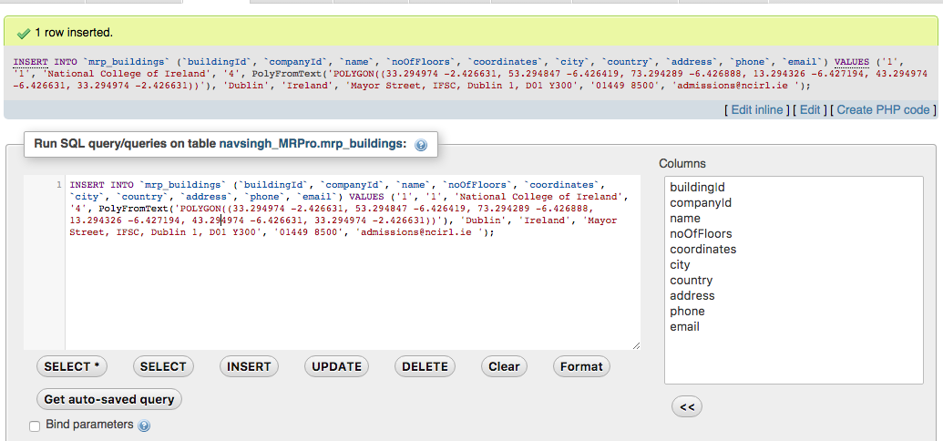

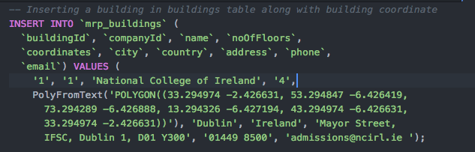

### Inserting data into mrp_meeting_rooms

[INSERT](https://eu72.hostblast.net:2083/cpsess5429043615/3rdparty/phpMyAdmin/url.php?url=https://dev.mysql.com/doc/refman/5.5/en/insert.html) INTO `mrp_meeting_rooms` (`meetingRoomId`, `buildingId`, `name`,`floorNumber`, `coordinates`, `capacity`, `type`, `phone`, `email`,`directions`) [VALUES](https://eu72.hostblast.net:2083/cpsess5429043615/3rdparty/phpMyAdmin/url.php?url=https://dev.mysql.com/doc/refman/5.5/en/miscellaneous-functions.html#function_values) ('1', '1', 'SCR1', '1',PointFromText('Point(83.294846 -4.426421)'), '71', 'ClassRoom', '01449 8500', 'scr1@ncirl.ie', 'Walk on your left hand side open the door close to stairs, the first room on your left')

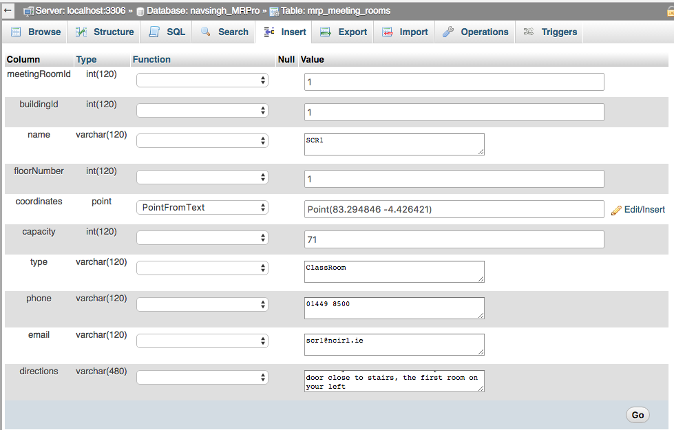

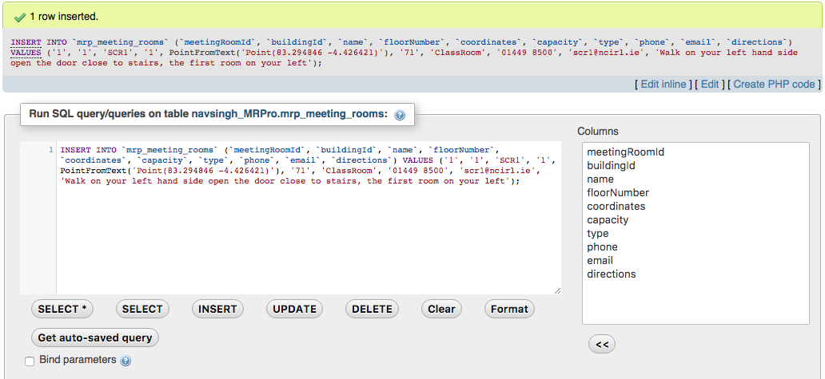

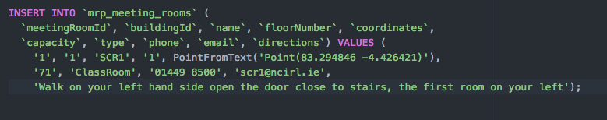

Inserting Data into mrp_companies Table

[INSERT](https://eu72.hostblast.net:2083/cpsess5429043615/3rdparty/phpMyAdmin/url.php?url=https://dev.mysql.com/doc/refman/5.5/en/insert.html) INTO `mrp_companies` (`companyId`, `name`, `headquarters`,`website`, `email`, `ceo`, `industry`, `tagline`) [VALUES](https://eu72.hostblast.net:2083/cpsess5429043615/3rdparty/phpMyAdmin/url.php?url=https://dev.mysql.com/doc/refman/5.5/en/miscellaneous-functions.html#function_values) ('1', 'National College of Ireland', 'Mayor Street, IFSC, Dublin 1, D01 Y300, Ireland, Europe', 'https://ncirl.ie', 'contact@ncirl.ie', 'Gina Quin (President)', 'Education', 'NCI - Changing Lives through Education')

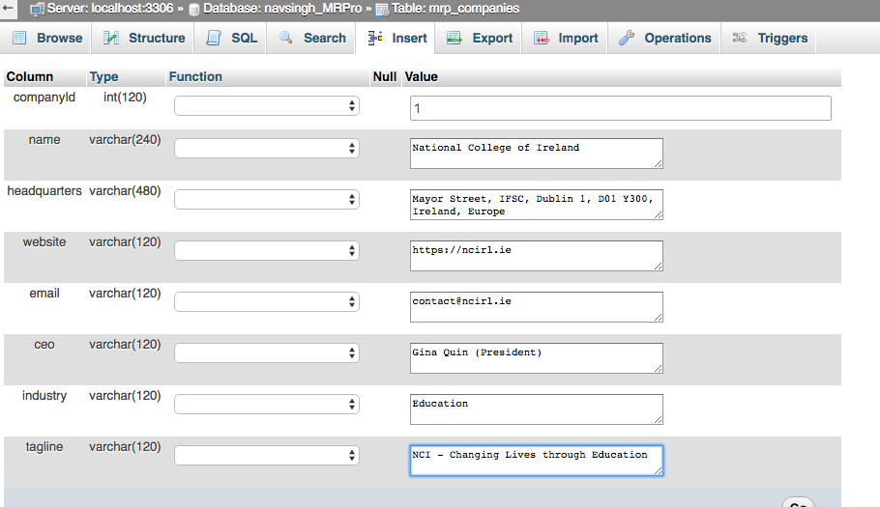

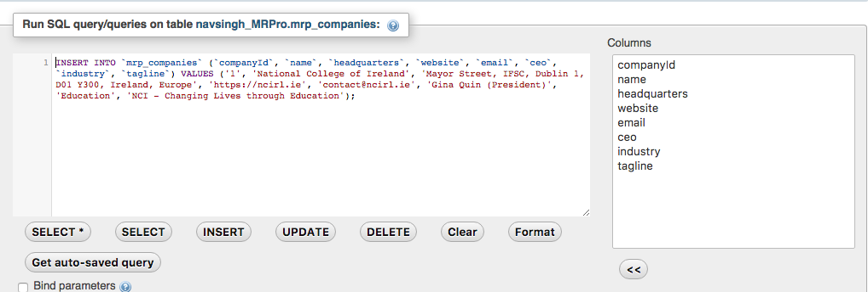

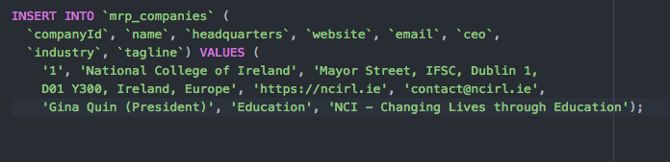

# Final Report Xcode

## Project Guide

This guide will help understand the requirement for opening and running this project-

MeetingRoom Pro is an ios (Swift) project, in order to use open the project code we require the following:

* Apple Mackbook (I am using Macbook Pro, 6 GB Ram, 2.3 GHz Intel Core i5)

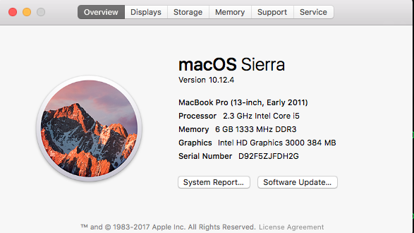

## Installing Xcode

Describe xcode and its features in detail in the final report.

Install Xcode on your Mac, using Appstore or this link: <https://developer.apple.com/xcode/ide/>

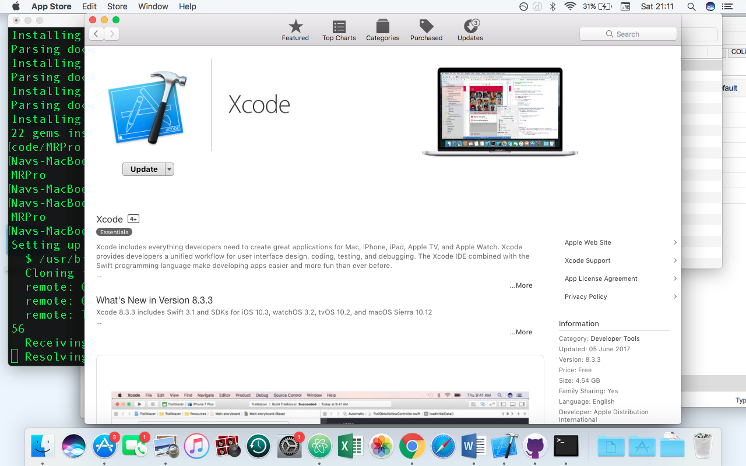

This is how a project in Xcode Ide looks like –

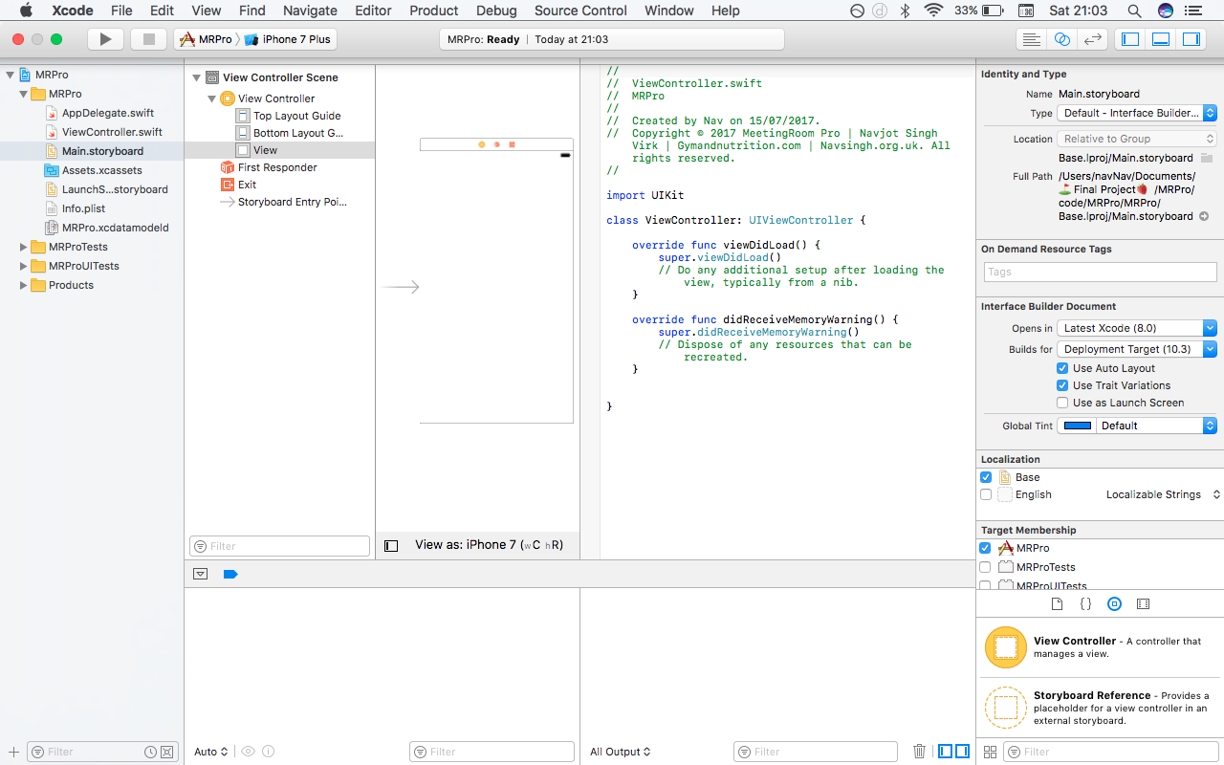

## Opening the Project

Use MRPro.xcworkspace file to open the project in xcode.

## Creating Project

Basic Steps involved in Project Creation

Step 1: File > New > Project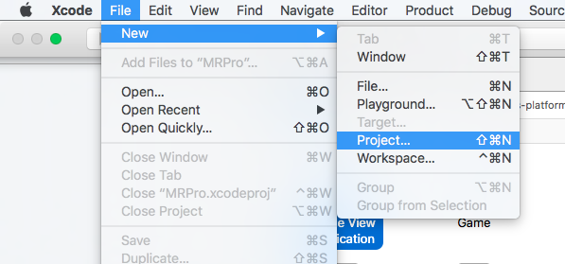

Step 2: Choose template – Single View Application > Next

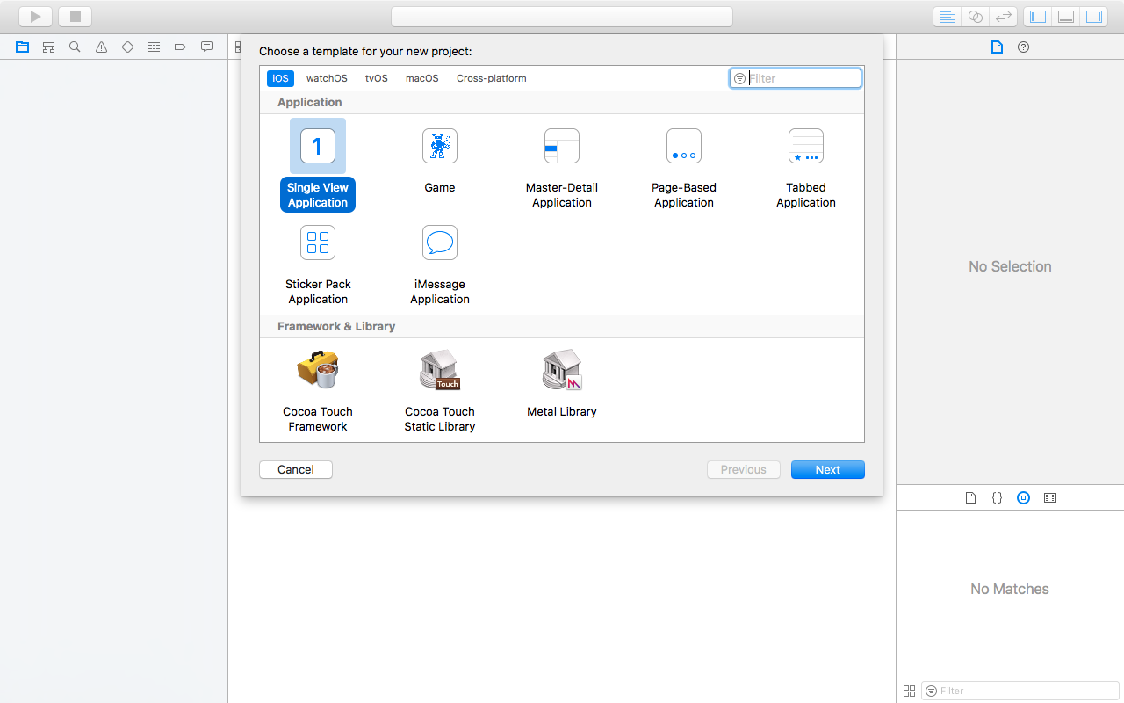

Step 3:

* Enter Product Name (aka. Project name) – MRPro (aka. MeetingRoom Pro)
* Select Team (Personal ios developer account – just signin with your apple id and xcode will take care of the rest)
* Organisation Identifier: ios.nsv (it could be anything (but unique) you like but it should usually make some sence and be short, simple and sweet like in this example- ios signifies its an ios app and nsv – Navjot singh virk)
* Select Language: Swift will be used for this project.
* Devices: Universal means the app will be supported on both iphones and ipads (you can also choose any one of them if you want to limit certain device type users).
* Others: Include UnitTests and UTests
* Press > Next

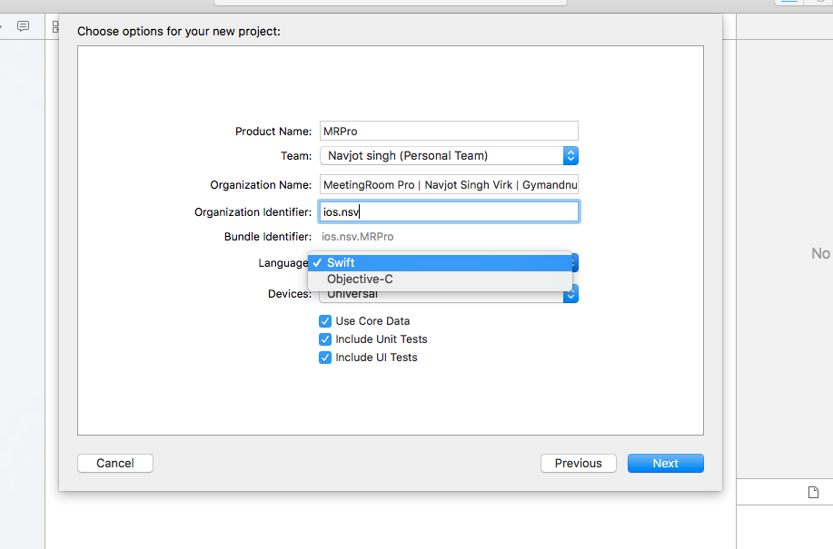

Step 4: Save the project on computer at location of your choice

Step 5: New Xcode project opens in a new window

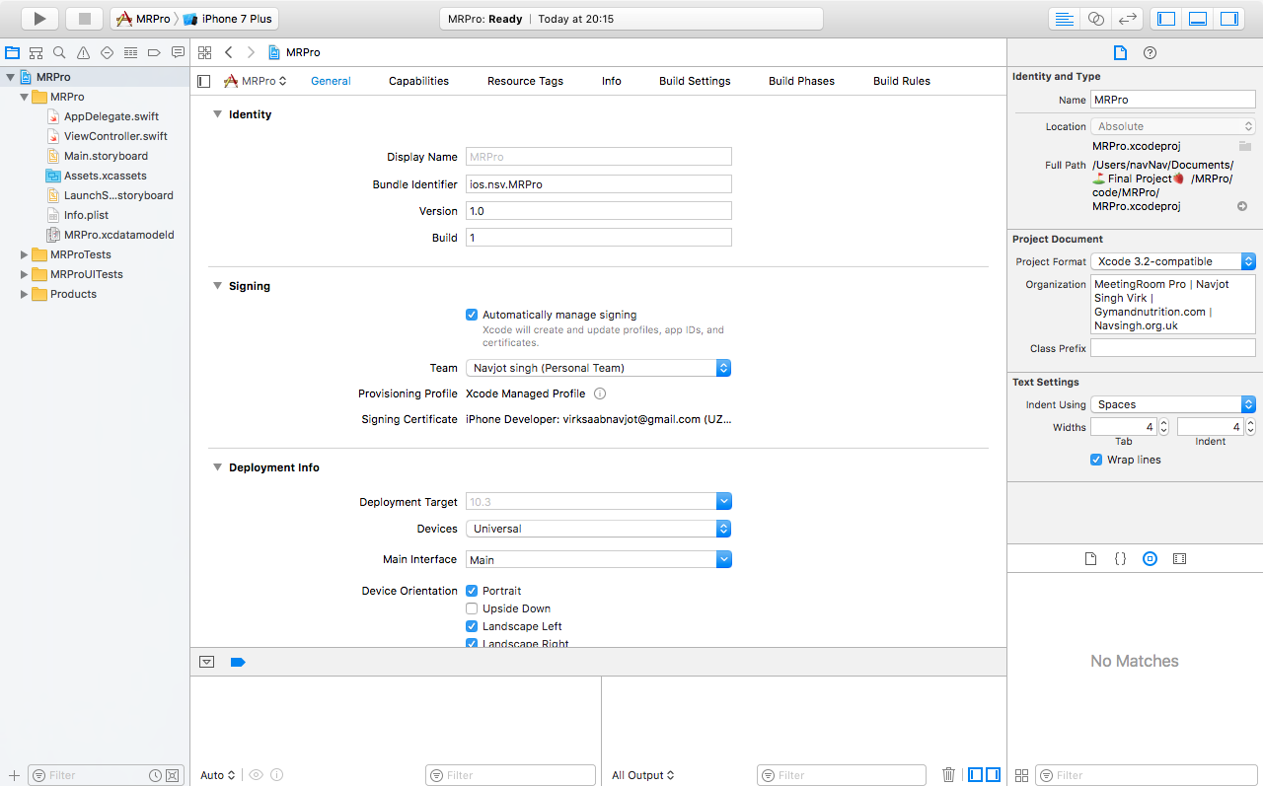

Step 6: At this stage project is ready and can be run on an emulator or a real ios device.

Step 7: Start making changes (write code)

## Cocoapods

Installing Cocoapods (on my computer which will allow us to use different useful cocoapods available on the internet).

* Open terminal
* Run this command: $ sudo gem install cocoapods (cocoapods is implemented in ruby so its included as a gem on our computer).

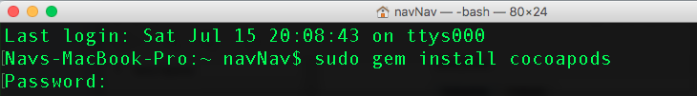

Explain cocoapods a bit in the final report

Explain what pods are, why they are needed, why they are useful?

## Create Pod File

In order to use Cocoapods we need to create a Podfile for our project.

* Open Terminal
* Navigate to the project folder
* To create the **Podfile** run this command in the terminal: **$ pod init**

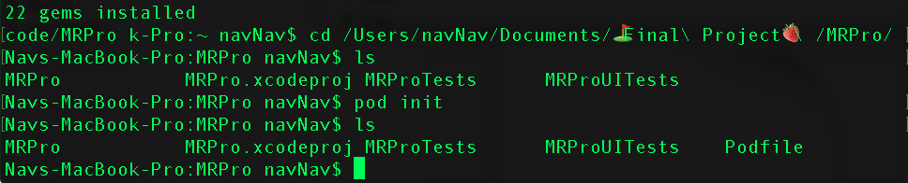

As we can see a Podfile was created when we ran the **‘ls’ command** second time to list the contents of the project folder.

* **Open Podfile** in an editor and write > **pod ‘SwiftyJSON’** to add our first pod that will help in handling JSON better (it’s a very popular library/pod among ios developer community when it comes to handling JSON in ios Swift).

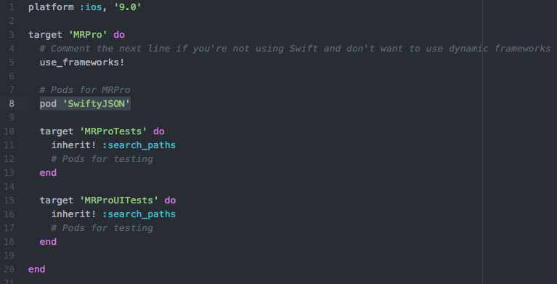

* Save Podfile > Run this command in terminal - **$ pod install** (this can take time (upto 1 to 2 hours depending on your network speed if cocoapods are not used on your computer before in order to setup cocopods master repo).

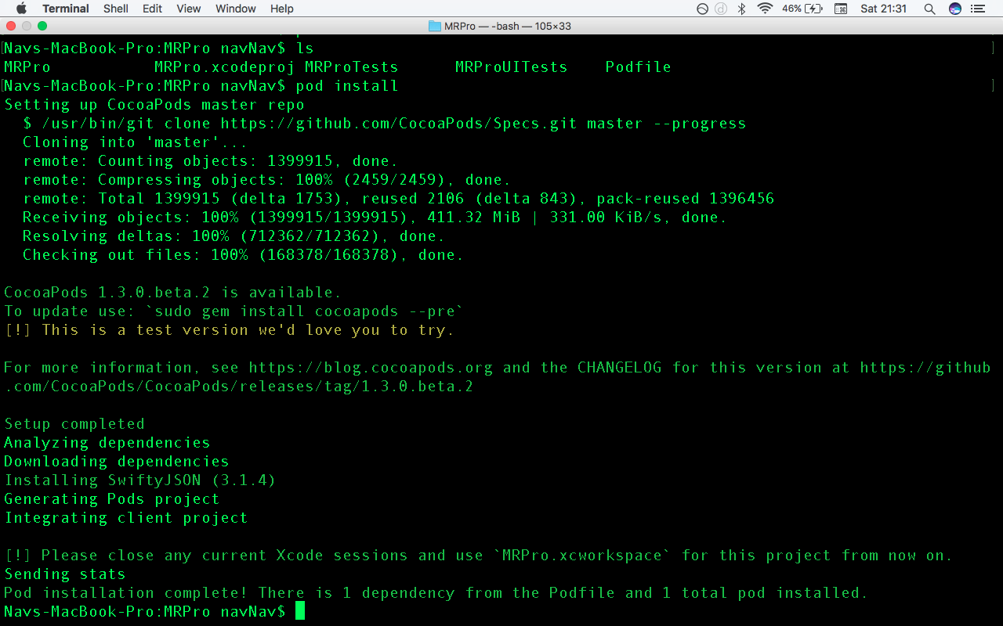

* Close project in Xcode.
* Open the newly generated – MRPro.xcworkspace. And now onwards everytime to open/work on the project MRPro.xcworkspace should be used instead of MRPro.xcodeproj
* Now at this stage the pod we installed will be available to use (Usage: import SwiftyJSON).
* All the other pods will be installed the same way.

Challenges, Build Fails and their solutions

1. Build fail every time after adding a new pod due to ChameleonFramework

Details

Build failed with 31 errors

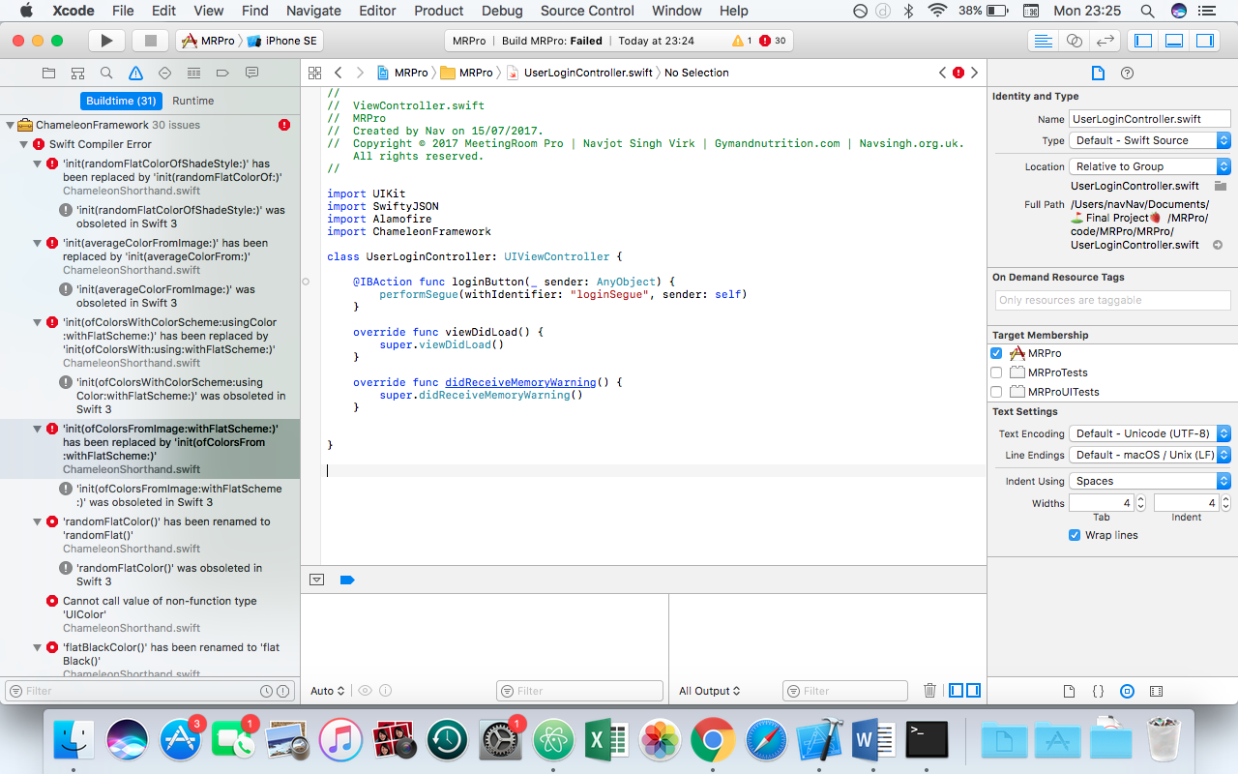

Clicking on one of the errors open the file in which errors exist. The problem here is target membership issue. As seen in the right hand pane of Xcode. Please refer to next screenshot.

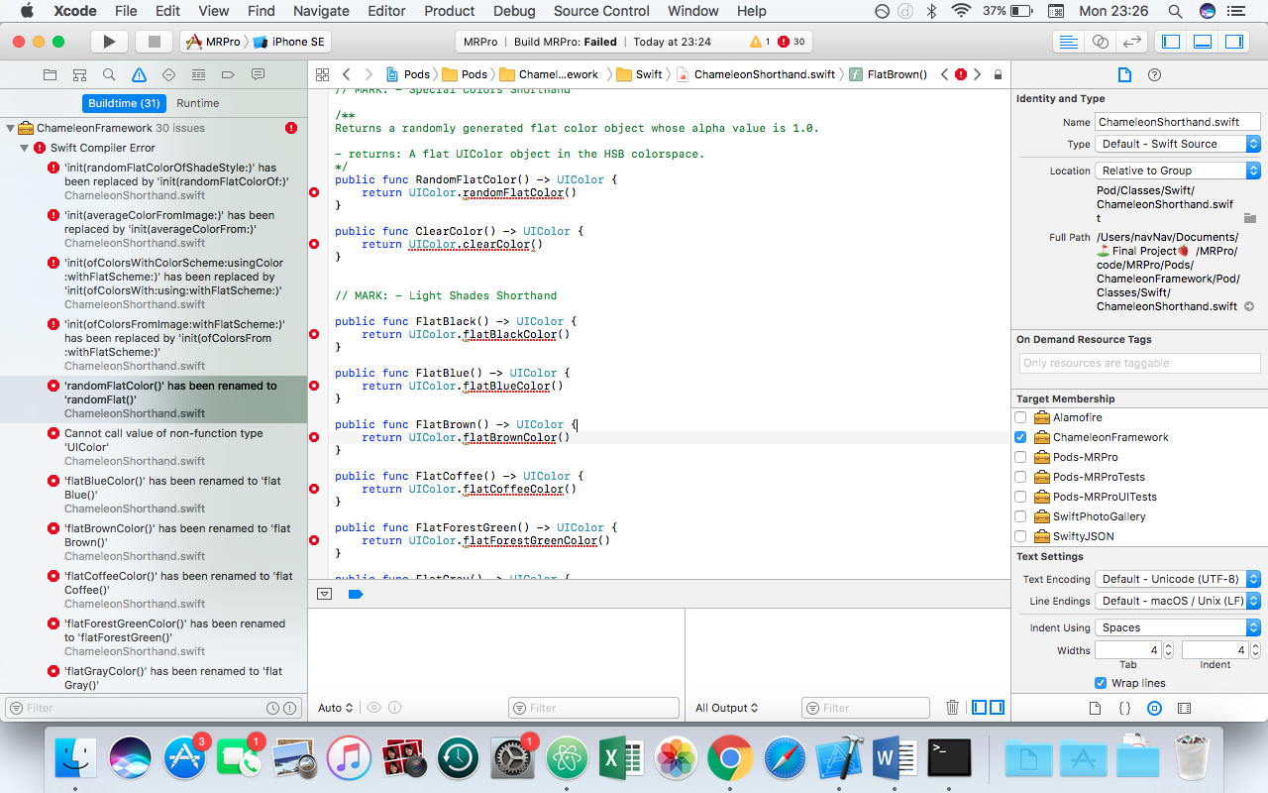

The problem was target membership is checked

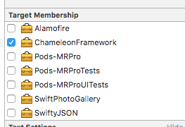

Solution Uncheck the target membership. And Clean Build

Cmd + B

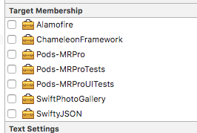

Results

The project is error free and build was successful.

